Jarvis — Architecture on Cloudflare
Oct 12, 2026 · @Saubhagya Ashish
Updated to match the final build. The sections from Component design onward describe what was built; the README in the repo has the current architecture diagram and run instructions.

Overview
Jarvis is a personal AI assistant that runs entirely on Cloudflare. It chats by text or voice, remembers durable facts about its user, and acts on its own by delivering a scheduled morning briefing.
Most AI demos are a chat box over an LLM. Jarvis is meant to show what makes an agent different: persistent identity and memory, work scheduled by the agent itself, and multi-step jobs that survive failures.
In scope
- Voice first: a 3D character you talk to (push-to-talk, spoken replies, expressions and lip-sync), plus a chat view of the same history
- Long-term memory of facts, tasks and notes, visible and editable ("What do you remember about me?")
- A daily morning briefing run as a durable Workflow, and reminders that Jarvis announces out loud
- Tools from OpenAPI specs and MCP servers the user connects, with approval for anything that writes
- Keeps working when the Workers AI free allowance runs out, and says so
Out of scope (future work)
- Built-in email, calendar or Slack (they can be connected as MCP servers instead)
- Multi-agent orchestration
- Semantic (vector) memory search
- Production authentication; the demo uses one anonymous agent instance per browser

Requirements mapping
Every required component is met with a Cloudflare product, and nothing outside Cloudflare is needed to run the core app.
Assignment component | Cloudflare product | How Jarvis uses it
LLM | Workers AI, Llama 3.3 70B | Chat with tool calling; fact extraction (JSON mode); the briefing. Whisper and Deepgram Aura-2 on Workers AI for speech
Workflow / coordination | Agents SDK on Durable Objects + Workflows | The agent coordinates chat, tools and schedules; a Workflow runs the multi-step briefing
User input (chat or voice) | Workers static assets (or Pages) + WebSockets | A voice screen with a 3D character (push-to-talk, spoken replies) and a chat view, both over one WebSocket and one history
Memory or state | Agent state + Durable Object SQLite | Synced state for the briefing, reminders and limits; facts, tasks, notes and connected APIs in the agent's SQLite
Supporting products: Wrangler for config and deploy, Workers Observability for logs.

Architecture
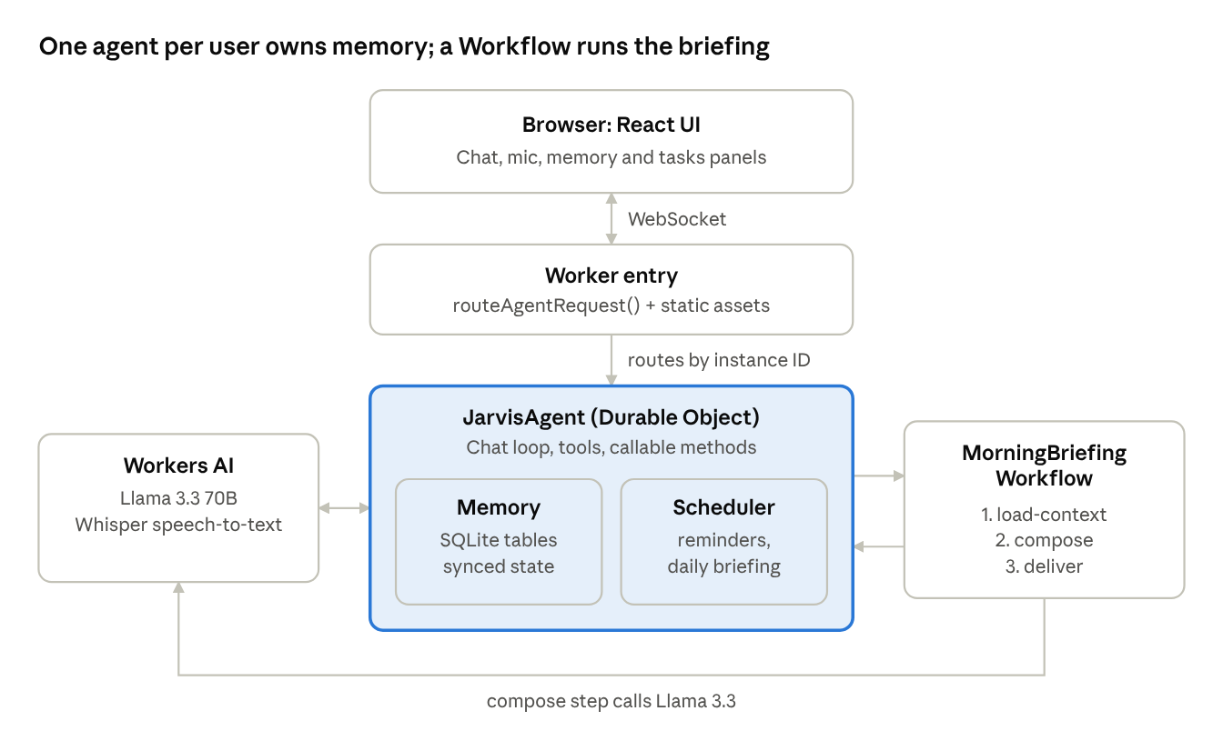
Jarvis architecture · 6 Cloudflare components
The browser holds a WebSocket to its own JarvisAgent. The agent calls Workers AI for chat and starts the Workflow, which writes the briefing back to the agent; the Workflow's compose step also calls Llama 3.3.
This diagram shows the original design. The final build adds backups for when the free allowance runs out (Ollama Cloud, Groq, the browser's speech APIs), connected APIs and MCP servers, and the 3D voice screen; the README has the updated diagram.

Component design
One Worker serves the app and routes each browser to its own agent. The agent owns all of that user's data and hands the briefing to a Workflow.
1. Frontend (React, served as Worker static assets)
- Two modes over one shared history: a voice screen (the default) and a chat view
- Voice screen: a 3D VRM character rendered with three.js and @pixiv/three-vrm, push-to-talk with Ctrl+Space or a button, captions, approval cards, history and memory drawers, and a character picker
- Chat view: the starter's useAgentChat UI with a mic button, a side panel (briefing, reminders, facts, tasks, notes) and an Integrations dialog
- Each browser gets a random, unguessable agent ID kept in local storage, so every visitor has their own Jarvis
2. Worker entry (src/server.ts)
- routeAgentRequest() sends /agents/jarvis-agent/<id> to the right Durable Object
- Serves the app and the character models as static assets
- Exports the agent class and the Workflow class
3. JarvisAgent (AIChatAgent, one Durable Object per user)
- Runs the chat loop: builds the prompt from memory, calls Llama 3.3 with tools, streams the reply
- Owns SQLite tables for facts, tasks, notes and connected APIs; the SDK stores connected MCP servers
- Exposes @callable() methods to the UI for memory, the briefing, reminders, transcription, speech and integrations
- Uses this.schedule() for reminders (one-off) and the daily briefing (cron, in UTC)
- Extracts new facts in the background after each turn (onChatResponse and the SDK's built-in queue)
4. Models
- Workers AI: Llama 3.3 70B (chat, tools, fact extraction in JSON mode, the briefing), Whisper large-v3-turbo (speech to text) and Deepgram Aura-2 (text to speech)
- Backups, only while the daily free allowance is used up: Ollama Cloud (gpt-oss:120b) for text, Groq Whisper for speech to text, and the browser's speech APIs as a last resort
5. MorningBriefingWorkflow (AgentWorkflow)
- Started with this.runWorkflow(). Steps: load-context (an RPC call to the agent through this.agent), then compose (Llama 3.3, retried up to 3 times with exponential backoff)
- Saves the briefing with step.mergeAgentState() and reports with step.reportComplete(). The agent posts it into the chat in onWorkflowComplete, and records a failure in onWorkflowError so the UI can show it

Memory and state model
All memory lives inside the user's own agent: small, UI-facing data in synced state, and growing data in SQL tables. No external database is needed.
Three memory tiers
Tier | Where | Lifetime | Example
Working memory | Recent messages in the prompt | Fitted to the token budget | Up to 20 recent turns
Long-term memory | facts table, in the system prompt | Until the user deletes it | "Is vegetarian"
Task memory | tasks and notes tables; reminders as schedules | Until done or deleted | "Call Raj at 3pm"
Synced state (this.state, pushed live to every open tab)
type JarvisState = {
timezone: string; // from the browser, e.g. "Asia/Kolkata"
briefingTime?: string; // daily local "08:00"; unset = off
briefingScheduleId?: string; // so a new time replaces the old cron
lastBriefing?: { text: string; createdAt: string };
workflowStatus?: "idle" | "running" | "failed";
briefingStartedAt?: string;
briefingError?: string | null;
inbox?: { id: string; text: string; firedAt: string }[]; // fired reminders
aiLimit?: { until: string; fallbackModel: string | null } | null;
};
SQL tables (this.sql, in the agent's own SQLite)
CREATE TABLE facts (id TEXT PRIMARY KEY, text TEXT, source_msg TEXT, created_at TEXT);
CREATE TABLE tasks (id TEXT PRIMARY KEY, title TEXT, due_at TEXT, done INTEGER DEFAULT 0);
CREATE TABLE notes (id TEXT PRIMARY KEY, body TEXT, created_at TEXT);
CREATE TABLE api_sources (id TEXT PRIMARY KEY, name TEXT, slug TEXT, base_url TEXT,
spec TEXT, spec_url TEXT, auth_header TEXT, auth_value TEXT, created_at TEXT);
The panel reads the SQL data through a callable method and refetches it when the agent broadcasts a change; state updates arrive by themselves. Chat history is stored by the SDK's chat agent.

Key flows
Five flows carry the app: a spoken turn, memory extraction after it, the morning briefing, reminders, and connected tools.
A. A spoken turn
- The user holds Ctrl+Space (or taps the mic). The browser records and converts the clip to 16 kHz WAV.
- The agent transcribes it with Whisper (or Groq), and the text is sent as the user's message.
- The agent builds the prompt from memory within Llama 3.3's 24K-token context and runs the model with the tools.
- Tool calls run against the agent's SQLite, its scheduler or connected APIs; destructive or writing calls wait for approval.
- The reply streams back and is spoken with Aura-2 (or the browser's voice) while the character's mouth follows the audio.
B. Memory extraction
- After the reply is saved, onChatResponse queues a background job with the user's message.
- Llama 3.3 in JSON mode returns new facts, given the known facts so paraphrases are skipped.
- New facts go into facts; the panel updates live and a "Jarvis will remember" note appears.
C. Morning briefing
- "Brief me every morning at 8": set_briefing converts the local time to a UTC cron (08:00 Asia/Kolkata is 30 2 * * *) and replaces any earlier schedule.
- At that time the agent starts MorningBriefingWorkflow (a "Run briefing now" button does the same on demand).
- load-context reads today's tasks, reminders, notes and facts from the agent; compose writes the briefing with Llama 3.3.
- The result is saved into agent state and posted into the chat, and Jarvis announces it on the voice screen.
- If compose still fails after its retries, onWorkflowError marks the run failed and the panel shows why.
D. Reminders
- set_reminder takes minutes from now or a local time, converts it to UTC and calls this.schedule().
- Upcoming reminders are listed in the prompt with their IDs, so the user can ask about or cancel one.
- When one fires, it goes into state.inbox and is broadcast; Jarvis says it out loud, shows it as a caption and sends a browser notification.
E. Connected tools
- An OpenAPI 3.x spec (pasted or fetched) becomes MCP-style tools: names from operationId, path parameters required, query and header parameters optional, the JSON body as a body argument.
- MCP servers are added with the SDK's addMcpServer(), which stores them and reconnects after restarts.
- Both are offered to the model alongside the built-in tools. Read-only calls run directly; anything else asks first. Their output is treated as data, not instructions.

Tools, prompt and configuration
Seven built-in tools act on Jarvis's own state. Connected APIs and MCP servers add up to 15 more.
Tool | What it does | Needs approval
forget_fact(id) | Deletes a fact | Yes
add_task(title, due_at?) | Creates a task | No
complete_task(id) | Marks a task done | No
add_note(body) | Saves a note | No
set_reminder(text, in_minutes | at) | Schedules a one-off reminder | No
cancel_reminder(id) | Cancels a reminder | Yes
set_briefing(time | off) | Turns the daily briefing on, off or changes its time | No
api_<name>_<operation> | Calls an operation of a connected OpenAPI spec | Unless it's a GET
tool_<server>_<name> | Calls a tool on a connected MCP server | Unless marked read-only
Keeping Llama 3.3's tool calling reliable
- The system prompt is rebuilt before every step, so memory reflects what the tools just did
- After a step where every tool call succeeded, the next step must answer in text
- Tool calls from earlier turns are left out of the history sent to the model
- Short IDs (t-1a2b3c4d) the model can copy back reliably
- A stream filter replaces "I don't need to call any function" replies with a real answer
- At most 5 steps per turn
wrangler.jsonc (main settings)
{
"name": "jarvis",
"main": "src/server.ts",
"compatibility_date": "2026-07-21",
"compatibility_flags": ["nodejs_compat"],
"ai": { "binding": "AI", "remote": true },
"assets": { "directory": "./public", "not_found_handling": "single-page-application",
"run_worker_first": ["/agents/*"] },
"durable_objects": { "bindings": [{ "name": "JarvisAgent", "class_name": "JarvisAgent" }] },
"migrations": [{ "tag": "v1", "new_sqlite_classes": ["JarvisAgent"] }],
"workflows": [{ "name": "morning-briefing", "binding": "BRIEFING_WORKFLOW",
"class_name": "MorningBriefingWorkflow" }],
"vars": { "OLLAMA_MODEL": "gpt-oss:120b" },
"observability": { "enabled": true, "logs": { "enabled": true }, "traces": { "enabled": true } }
}

When the free allowance runs out
The Workers AI free tier is 10,000 neurons a day per account. Two full test runs use it up, so the app has to keep working without it and say so.
- Chat, fact extraction and the briefing fall back to Ollama Cloud. The agent remembers the limit until it resets (00:00 UTC) and skips Workers AI meanwhile; a banner explains what's happening
- Speech to text falls back to Groq Whisper, then to the browser's own recognition
- Spoken replies fall back to the browser's own voice
- Spoken replies are capped at about 600 characters, since Aura-2 costs about 2,700 neurons per 1,000 characters

Cost, scale, reliability, security and observability
- Cost: agents hibernate when idle, Workers bill CPU time rather than time spent waiting on the model, and speech is capped. An idle Jarvis costs close to nothing.
- Scale: one Durable Object per user, so users never share a lock or a database; the platform scales by adding instances.
- Reliability: state survives restarts (SQLite-backed). Workflow steps and fact extraction retry on failure, and every model has a backup.
- Consistency: each user's data has a single writer, their agent, so there are no race conditions.
- Security: no login (each browser gets an unguessable ID). Destructive and writing tools need approval, external tool output is treated as data, and API keys stay on the server, never sent to the browser or the model.
- Observability: Workers Logs and Traces, structured JSON logs (facts extracted, briefing posted, limit hit), and the Workflows dashboard for each briefing run.

Trade-offs, alternatives and how it was built
The main choice was to keep everything per user inside one agent, trading cross-user queries for simplicity and consistency.
Alternatives considered
Option | Why not chosen (for now)
Store memory in KV | Eventually consistent; a fact saved in one turn might be missing in the next
Store memory in D1 | Good for cross-user queries, which Jarvis doesn't need; adds a network hop
Vectorize for memory | Better recall at scale, but a few hundred facts fit in the prompt; future work
Run the briefing inside the agent | Works, but no per-step retries or visible runs
Host each OpenAPI spec as its own MCP server | More moving parts, and an endpoint that carries API keys
A speech-to-speech model (Gemini Live, OpenAI Realtime) | Would bypass Jarvis's memory and tools, and replace Llama 3.3
Browser speech recognition alongside every recording | Would send every clip to Google; it's only the last resort
Workers Paid instead of backups | Simplest for production; the backups keep the free demo working
Known limitations
- No sign-in: clearing site data starts a new Jarvis
- Reminders are delivered while a tab is open (with a browser notification); push delivery isn't built
- The briefing's cron is fixed in UTC, so daylight saving shifts it by an hour until it's set again
- Backups send data outside Cloudflare (Ollama, Groq; Chrome's own recognition goes to Google)
- OpenAPI 3.x only, at most 15 external tools
- Each character is a 15–19 MB download the first time
How it was built
- Design review, then a first deploy from Cloudflare's agents-starter on Llama 3.3
- Memory: facts, tasks, notes, background extraction, the side panel
- The agent acting on its own: the briefing Workflow and reminders
- Backups for when the free allowance runs out
- Voice: speech to text, spoken replies, and their backups
- Integrations: OpenAPI specs and MCP servers
- The 3D voice screen
- Each phase ended with a deploy and an end-to-end smoke test (see scripts/ in the repo)
Sources
- Cloudflare Agents
- Agents docs and quick start
- Durable Objects, Workflows, Workers KV, Workers

